FTS setup for Four Quadrant Lambdoma Midi Keyboard
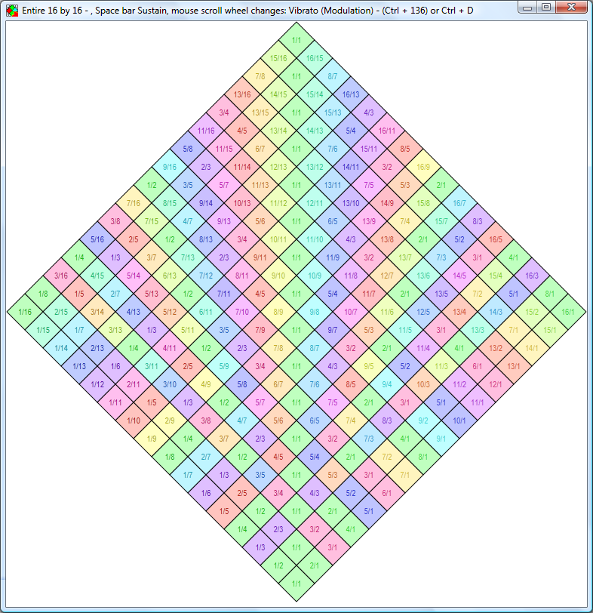

How to install the FTS Lambdoma software on your computer

Run FTS_Setup_Midi_Lambdoma - usually with a double click - to start the setup process. You can find this on the CD which comes with your keyboard

Select Accept then Next to accept the license agreement. Then select the extras to install – if unsure just keep everything selected here. Press Next.

Glance at the install directory to see if that is where you want to install it - the standard setting will be suitable for most: C:\Programs\Tune Smithy Lambdoma 4
Or on XP: C:\Program Files\Tune Smithy Lambdoma 4\

Press Install. That’s it done.

This installer is system friendly. It doesn't change any system files or settings. All it does is to install the FTS Lambdoma software into its own folder, add shortcuts if you want them, and add a file association for Tune Smithy files (file extensions: .ts, .tsProj and .rly).

When you first start FTS Lambdoma

Make sure you plug the USB MIDI device into your computer and keyboard. The software should auto detect it.

To run the program, look for the red snowflake icon on your desktop, or go to Start >> All Programs >> Tune Smithy Lambdoma 4 >> Tune Smithy Lambdoma 4

When it first runs you will be asked to enter your unlock key.

Introduction to the software

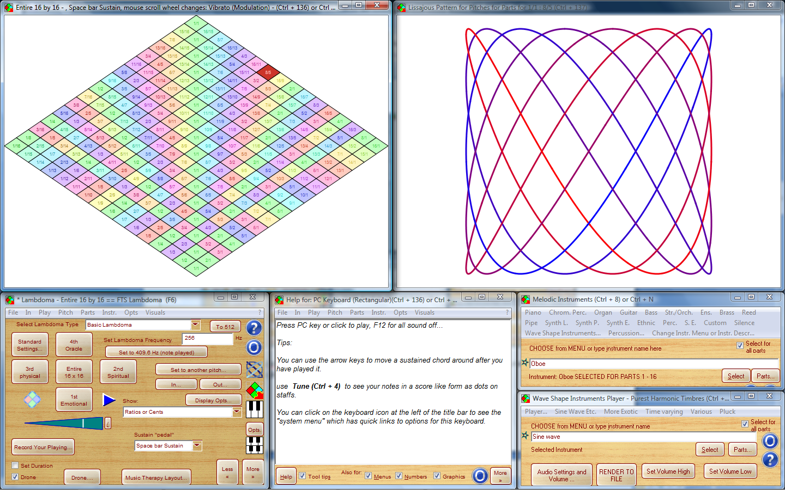

You see the Lambdoma on-screen keyboard at top left. This will light up when you play notes from your keyboard. At top right you see the Lissajous patterns.

At bottom right you see the instrument menus.

In the middle, if there is enough space on your screen, you get a help window as in the screen shot above. On smaller screens you need to press the F1 key on your keyboard to show the help.

At bottom left you see the main window.
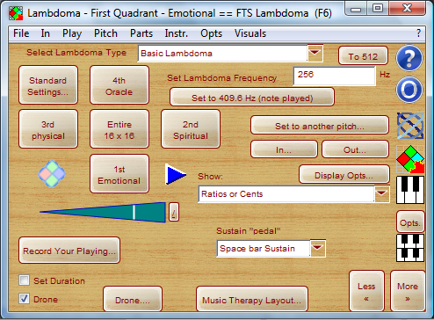

Here you can select the quadrant, set your key note – the pitch of the 1/1 of the keyboard – choose how to show the notes on the keyboard and so on.

BasicLambdoma, Rhythms and Bounce

In the drop list at the top of the window you can choose between the Basic Lambdoma, Lambdoma with Rhythm and Lambdoma with Rhythm and Bounce.

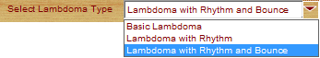

If you want to hear the harmonic polyrhythms, choose “Lambdoma with Rhythm”. You can then use the Play button to stop or start the rhythms.

The Bounce feature shows bouncing balls which can help you to sing or play in time with the rhythms.

Volume – what to do if notes are too quiet or don’t sound at all

You can vary the overall volume of the notes using the volume control


You also have a volume control for your computer as a whole which you find in the task bar. It may look something like this:

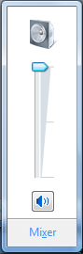

Also if you hear no sound at all - make sure that the sound for your computer isn’t muted.

You can also get to this volume control from within FTS Lambdoma. To do that go to Play >> Volume Control for your PC

Synchronization of bounce with sound

On some computers you may find that the bounce is out of sync with the sound – each bounce happens a fraction of a second after the note is played.

If this happens to you, go to the Bounce Preferences (Ctrl + 220) window and choose Set Bounce Synchronization delay. You can then vary the amount of the delay if needed. Most often however, you can just leave it at its default setting (200 ms or a fifth of a second).

This problem is most likely to happen with the Microsoft GS Wavetable Synth, and when this issue occurs the latency is usually a fifth of a second (though with other computers using the same synth the issue may not occur at all, delay too short to be easily noticeable).

Reset to “Factory Settings”

You can do a reset using File >> Reset Everything (like reinstall)

Updates.

When updates are available, you can download the latest version of the FTS Lambdoma software here:
http://robertinventor.com/software/tunesmithy/fts_lambdoma.htm

Out Devices

Most computers only have one device installed to play the notes. But some may have a choice of different midi devices.

You can see these listed in the Out Devices window. Use Ctrl + 41 to show it.

On a modern computer you can expect to play the Lambdoma notes at the correct pitch (it will use DirectSound or a midi capable soundcard). But some optional extra devices you can install may not have this capability. To test your currently selected out device, use Play >> Out Device Capabilities Wizard.

In Devices

Your USB Midi in should get selected automatically. If you have several midi input devices on your computer you may want to choose which one to connect your keyboard to, and if so you can do that in the In Devices window (Ctrl + 249)

Changing to a single quadrant keyboard – or back to a 4 quadrant keyboard

If you attach a single quadrant keyboard, then please go to the In Devices (Ctrl + 249) window, highlight your In Device, and then in the drop list below, select “SINGLE QUADRANT LAMBDOMA KEYBOARD with key highlighting”

When you want to change back to a four quadrant keyboard, then in the same window, select “FOUR QUADRANT LAMBDOMA KEYBOARD with keyboard highlighting”.

Be sure to contact me with any questions or suggestions. support@robertinventor.com

Also included on the CD

Installer for Lissajous 3D

Look for Lissajous_3D_Setup and run it to install Lissajous 3D on your computer.

You need this if you want to show the Lissajous patterns in 3D as you play chords on the Lambdoma keyboard. These are like the 2D patterns taken into another dimension.
Other extras on the CD

Most users don’t need these

See the “Optional Extras” folder on the CD.

Add other audio formats If you want to record to some of the rarer audio formats, such as .ogg (replacement for .mp3 preferred by some musicians) then this lets you do that.

Add CSound support - This adds extra instrument sounds that may be of interest to some users. Used mainly for recordings only though you can also play them in real time with CSoundAV.

Your unlock key for FTS Lambdoma also gives you:

Bounce Metronome Pro

Your “Complete” unlock key also unlocks Bounce Metronome Pro. Some of its features are related to the Lambdoma music therapy ideas.

Please Note – Bounce Metronome Pro isn’t designed to be played from your Lambdoma keyboard

You can download Bounce Metronome Pro from its web site at http://bouncemetronome.com

It installs as a separate program with its own desktop shortcut and program folder.

After you install it, look in the drop list of metronomes in its main window.

The ones of particular interest for the Lambdoma are:

Harmonic Polyrhythm Metronome – plays the same rhythms you get in the Rhythms version of the FTS Lambdoma – but slightly differently presented.

Harmonic Rhythm Cycle Metronome - this plays several harmonic metronomes one after another in a cycle.

Theremin's Rhythmicon (harmonic polyrhythms) - again same idea, pitches in harmonic or subharmonic series. This time it gets set up with sixteen different rhythms and pitches initially all silent. Press keys 1 to 9, 0 and the letter keys of top row of your PC keyboard to silence or play the rhythms.

Tune Smithy

FTS is short for “Fractal Tune Smithy” and originally the FTS Lambdoma was developed as one of the tasks of FTS.

Now that I’ve developed the stand alone FTS Lambdoma you no longer need the complete FTS program.

For Lambdoma work you are recommended to use the FTS Lambdoma 4 included on the CD, which is also more up to date.

However you may find the software useful or interesting if you are intrigued by fractal tunes, or want to explore microtonal keyboard retuning, or some of the other tasks of FTS 3.

You can unlock FTS 3 with the same key you used to unlock FTS Lambdoma 4. It installs as a separate program with its own desktop shortcut and program folder.

You get it here, or find out more about the software, at: http://tunesmithy.co.uk

